
STUDENT CASE STUDY EXECUTION REPORT
Department | CSE
Subject | DSA-2
Academic Year | I-III Semester (2025-26)
Faculty Name | Dr.N.Chaitanya Kumar
Student Name | CH SAI PRASANNA
Roll number | 2520030608
Branch | CSE
Course Outcome | CO-1

Case Study Topic: AgroChain Smart Crop Registry System using BST, AVL Tree, B-Tree and B+ Tree
Work Done Summary:
In this case study, a Smart Crop Registry System was developed for the AgroChain agricultural supply chain platform. The system manages crop batch records using Binary Search Trees (BST) and AVL Trees to support efficient insertion, deletion, and searching operations. AVL Trees ensure balanced storage of crop records, maintaining O(log n) performance for dynamic operations.
Multi-way search trees such as B-Trees and B+ Trees were also applied for efficient indexing and retrieval of large agricultural datasets. B-Trees improve storage efficiency while B+ Trees support range-based queries for crop records and inventory analysis
Implementation Details:
· Implemented Binary Search Tree (BST) for crop batch insertion, searching, and deletion.
· Implemented AVL Tree with balancing operations and automatic rotations.
· Demonstrated inorder traversal to display crop records in sorted order.
· Applied AVL balancing to maintain logarithmic search complexity.
· Demonstrated B-Tree indexing for efficient storage of crop information.
· Applied B+ Tree concepts to perform range-based retrieval of crop records.
· Compared BST and AVL Tree performance for inventory management.

Result: Output :
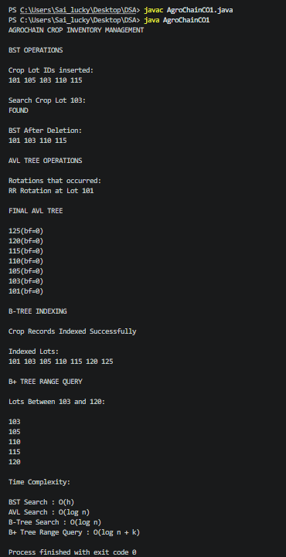
The AgroChain Smart Crop Registry System successfully managed crop records using BST and AVL Trees. AVL Trees maintained balanced inventory records, while B-Tree and B+ Tree structures improved indexing and range-based retrieval of crop data.
Time Complexity:
• AVL Insert : O(log n)
• AVL Search : O(log n)
• AVL Delete : O(log n)
• Inorder Traversal : O(n)
Compared to a normal BST, AVL Trees ensure balanced performance and efficient crop inventory management operations.

GitHub Link:
https://github.com/PRASANNA18-sai/AgroChain-Smart-Agriculture-Supply-Chain-Management-System

Student Signature | Faculty Signature
________________________ | __________________________

